Python Functions

1. Write a function to calculate the factorial of a number (non-recursive).

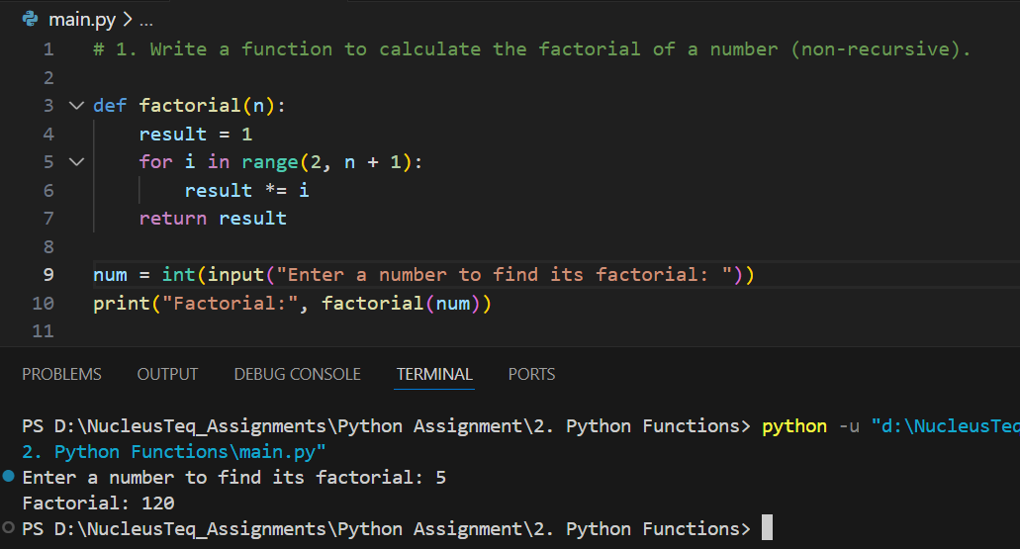

2. Define a function that checks whether a string is a palindrome.

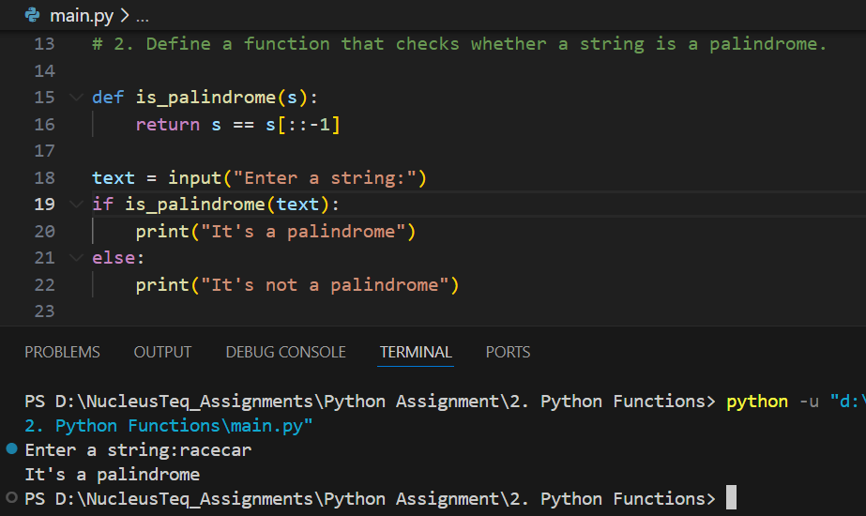

3. Write a function that accepts a list and returns the sum and average of the numbers.

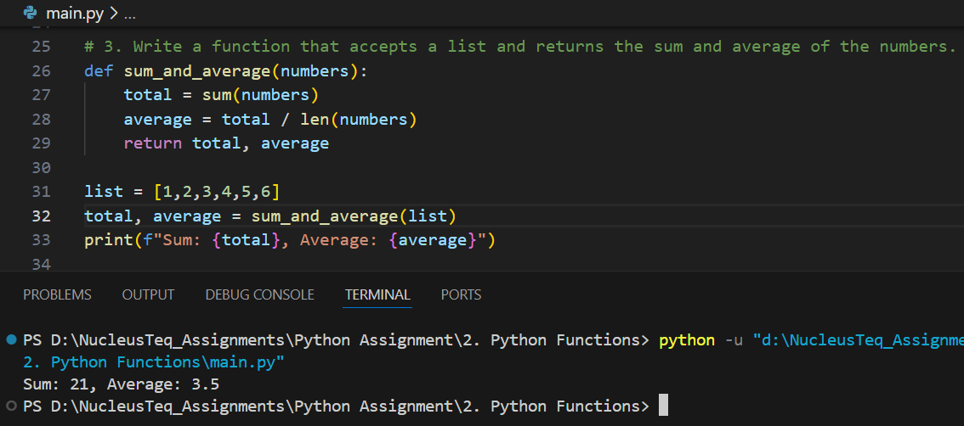

4. Create a function that returns the nth Fibonacci number using recursion.

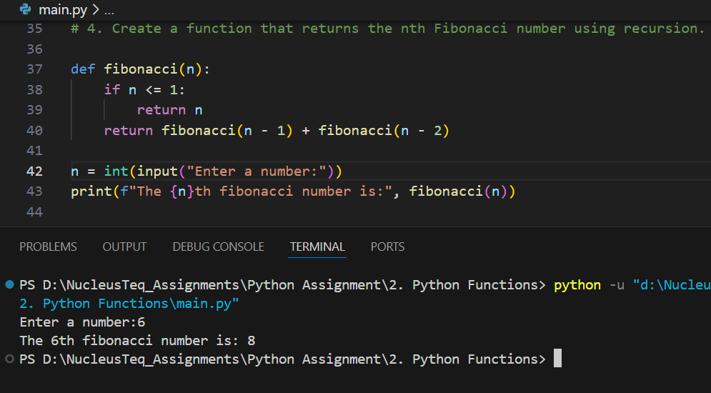

5. Define a function to count the number of vowels in a given string.

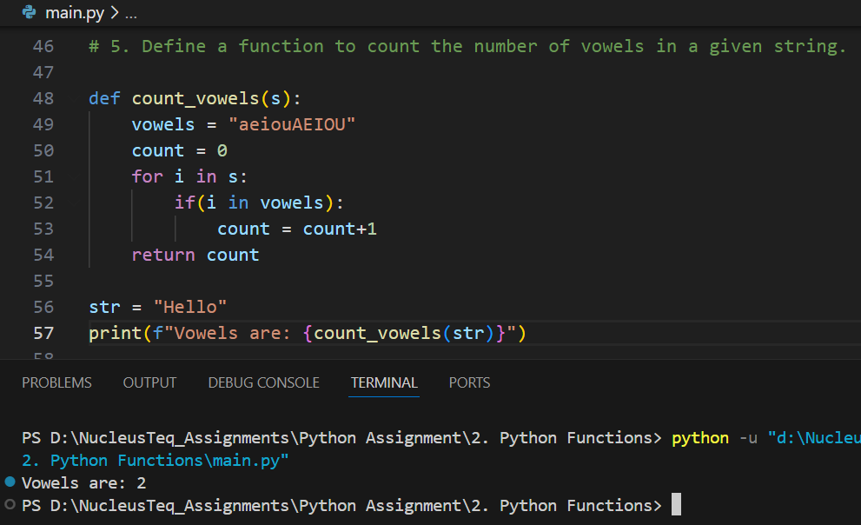

6. Implement a decorator that measures execution time of any function.

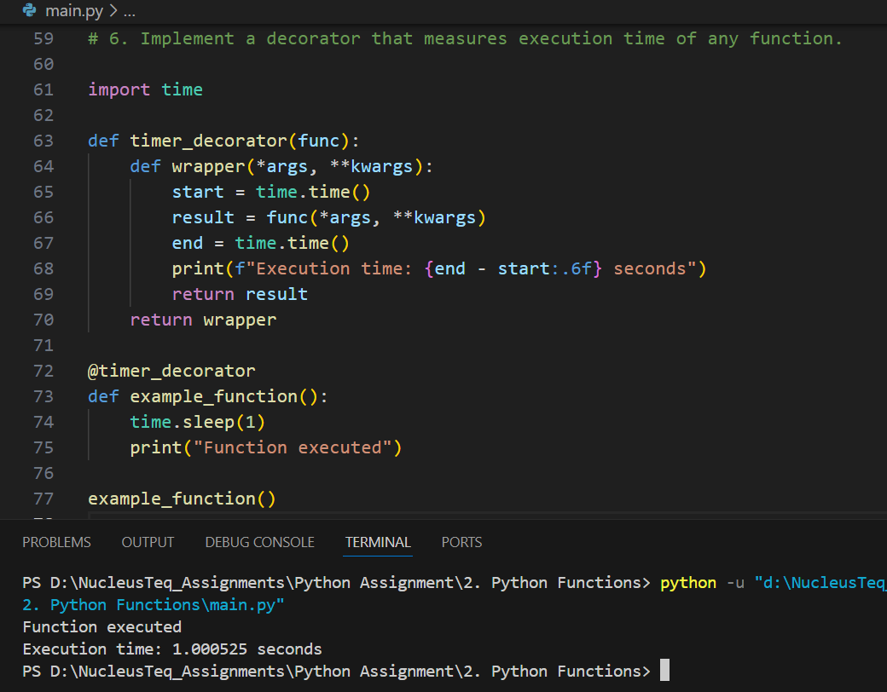

7. Write a recursive function to solve the Tower of Hanoi problem.

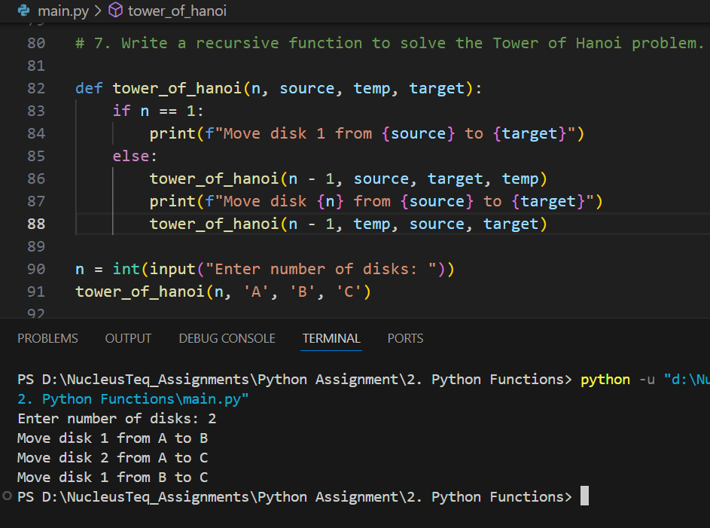

8. Implement a function that uses variable-length arguments to sum any number of inputs.

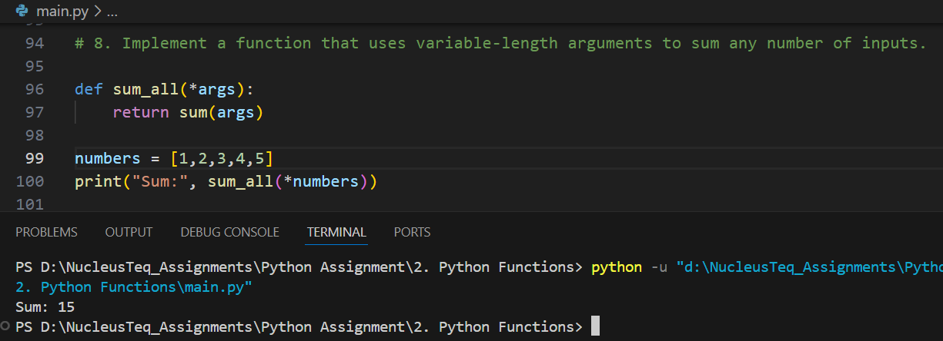

9. Write a function that flattens a nested list using recursion.

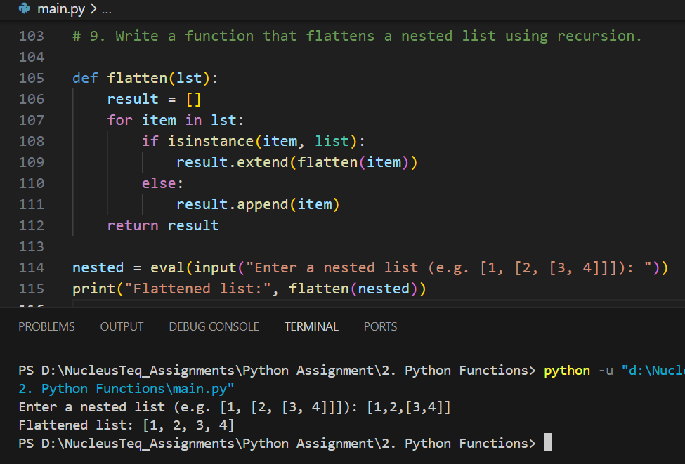

10. Implement a memoized version of the Fibonacci sequence.

